**Welcome Home Page**

* Based on credential and user role page will redirect to next level. The application has below four views:
* Admin
* Customer
* Manager
* Engineer

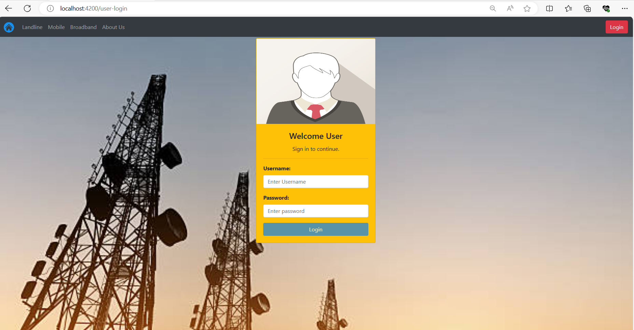

* If user enter wrong credentials, application responded as invalid credentials:

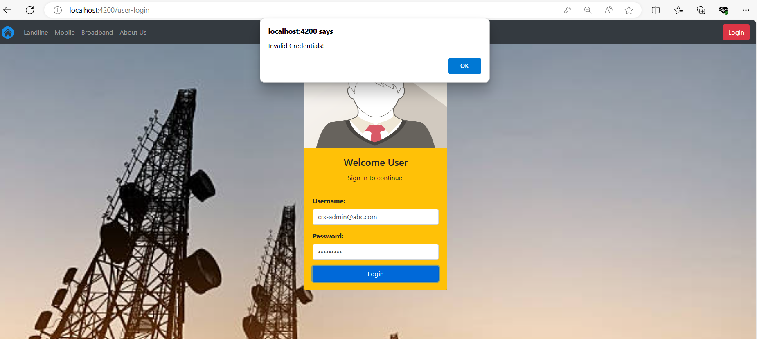

* Let’s go with **Admin**: once admin enter correct credentials the application redirected to next page and shown below mentioned option for admin:
* Create User
* Show Managers
* Show Engineers
* Show Customers

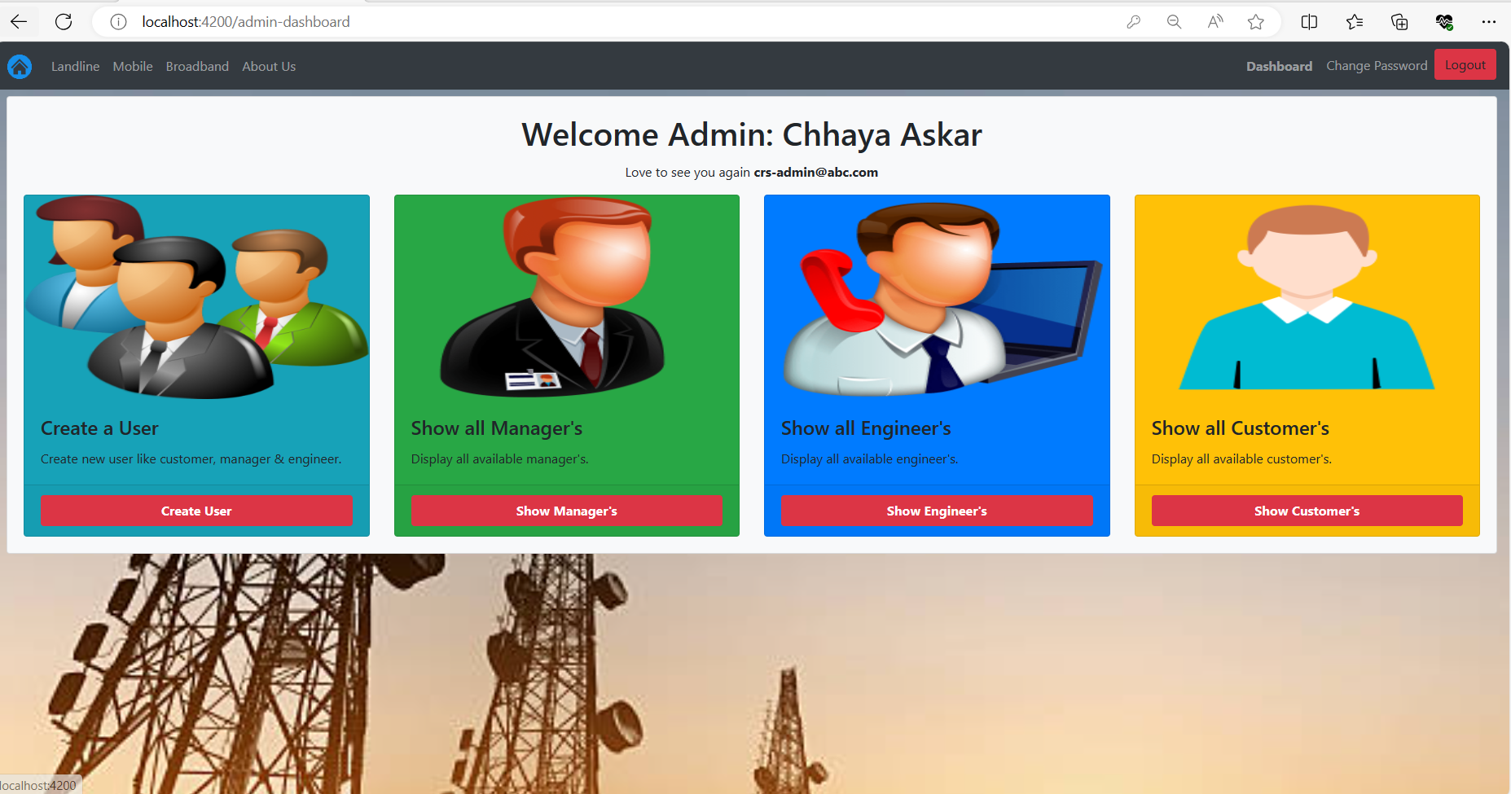

* **Create User** option show the registration page where new Customer, Engineer or Manager register, Lets create users like manager, customer, and Engineer
* Created new Customer:

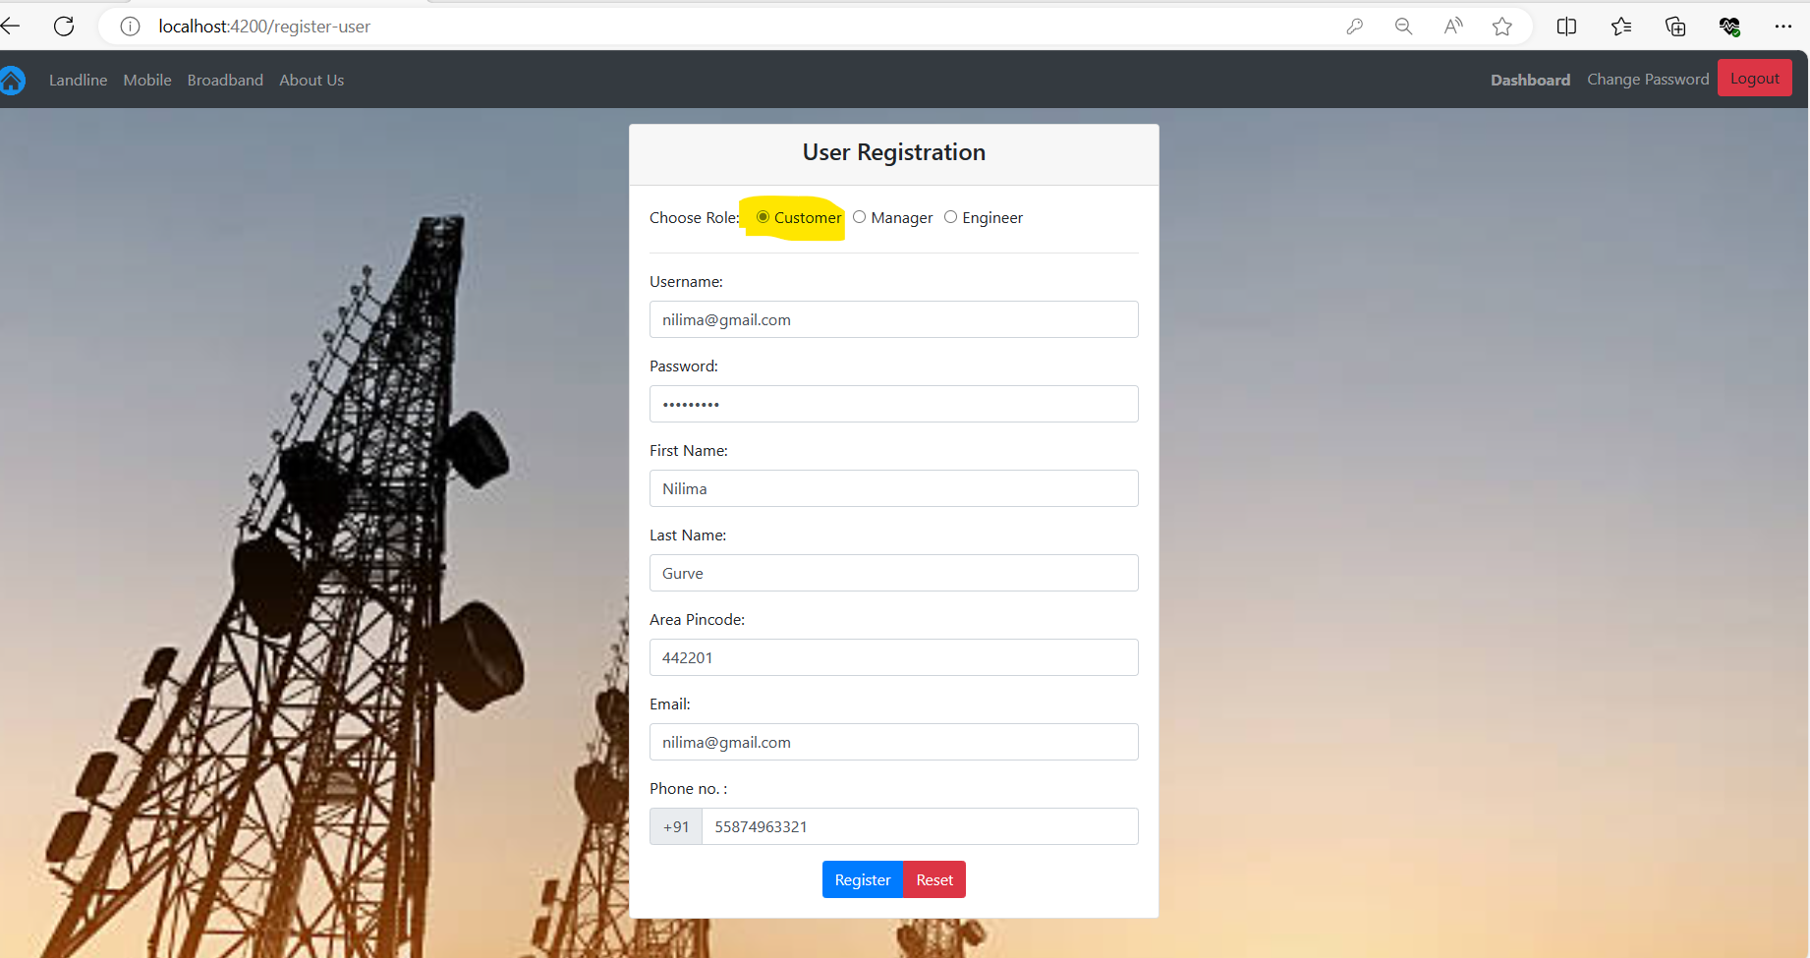

* Created new Manager:

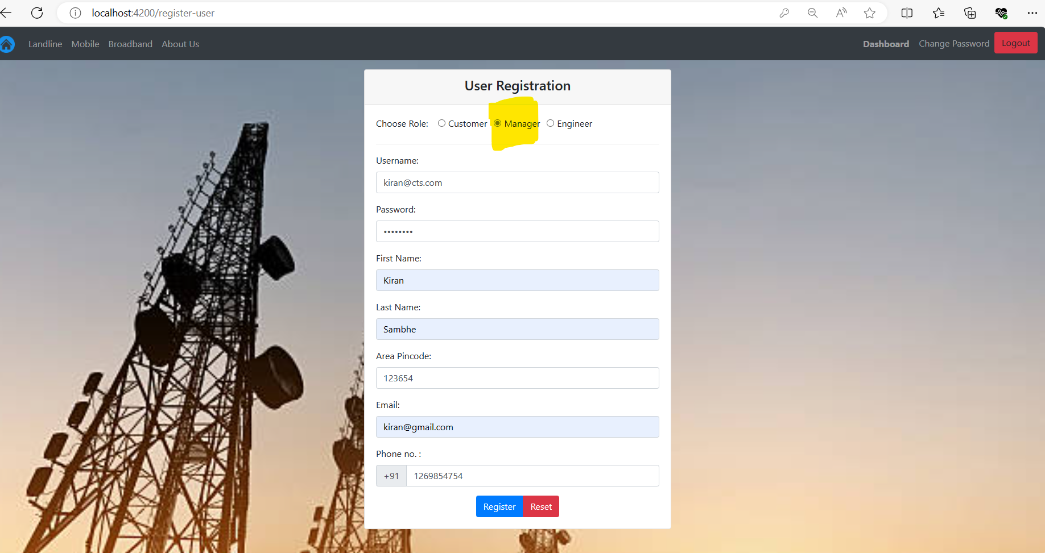

* Created new Engineer:

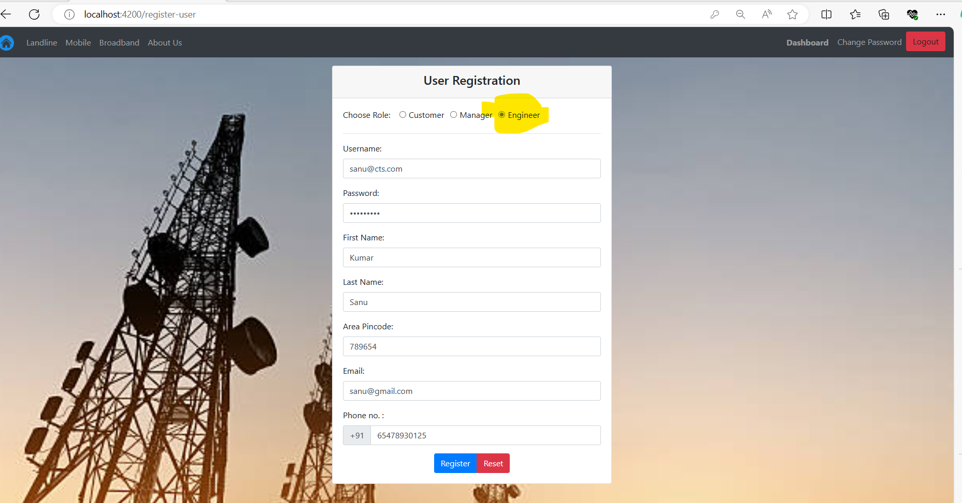

* **Show** **Manager option**: Show All the Available manager, Our Newly created manager details as well shown here:

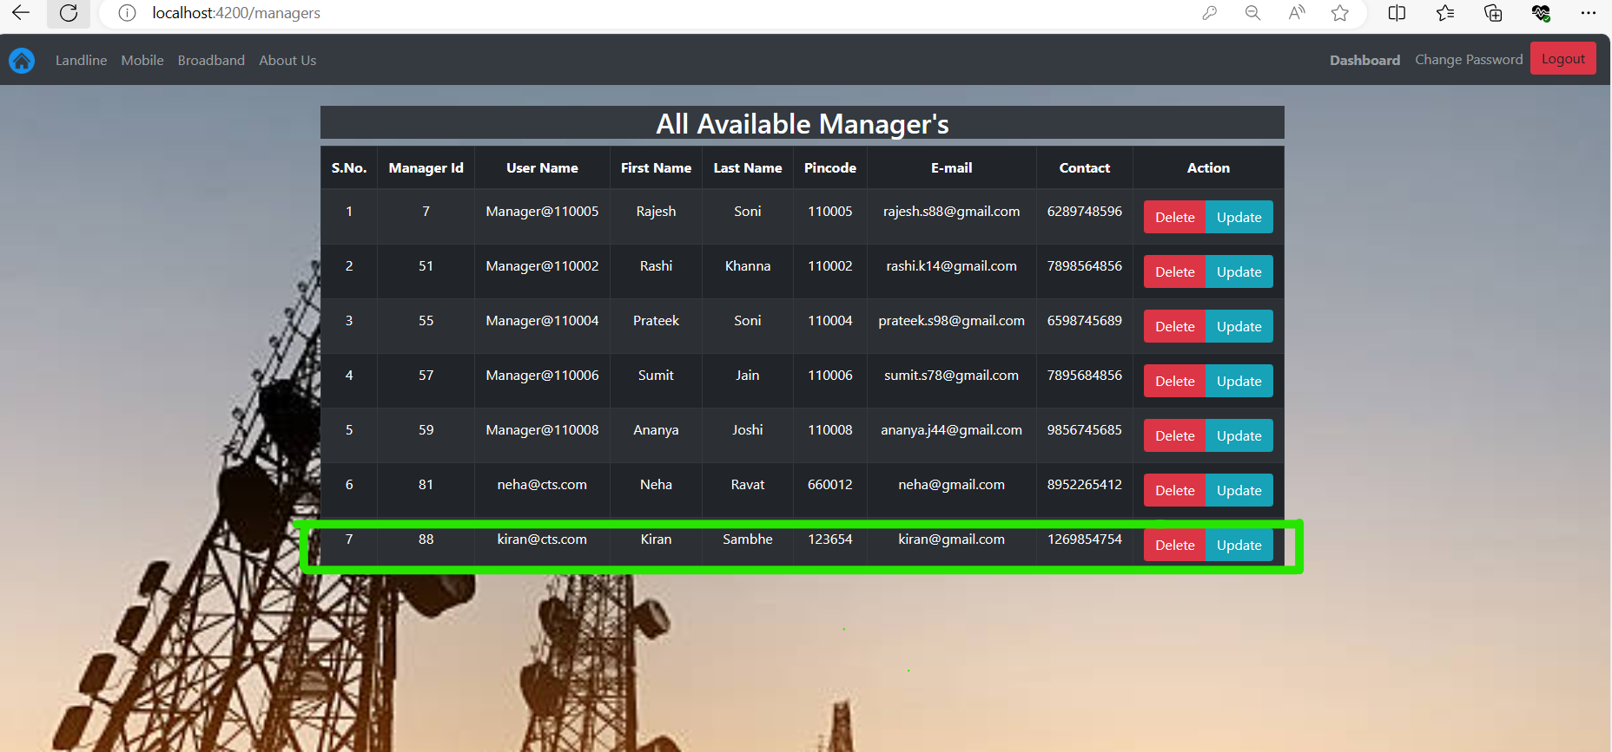

* **Show** **Customer option**: Show All the Available manager, Our Newly created customer details as well shown here:

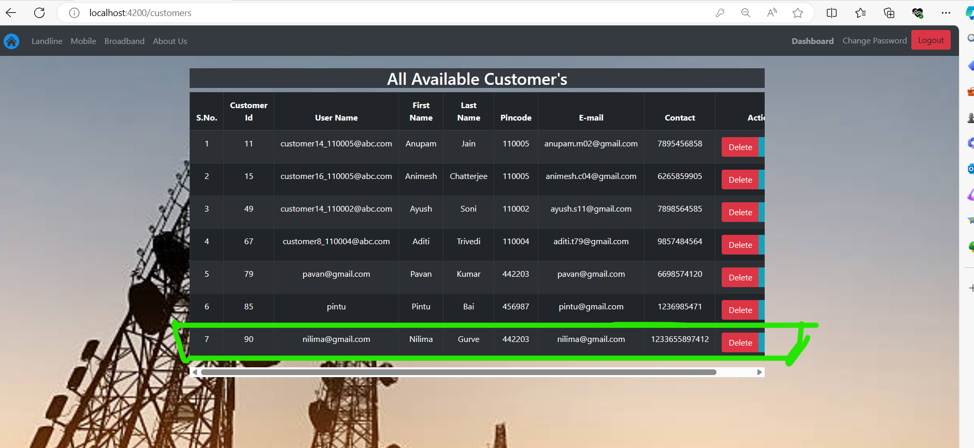

* **Show** **Engineer option**: Show All the Available manager, Our Newly created engineer details as well shown here:

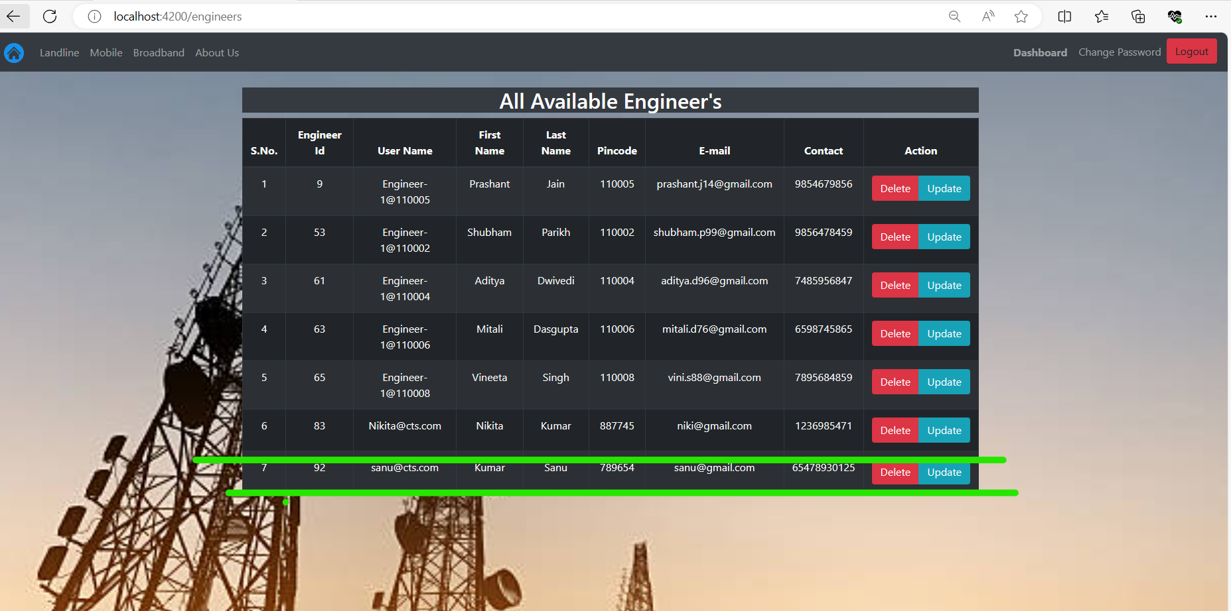

* Let’s Logout as Admin, and try to login as newly created customer:

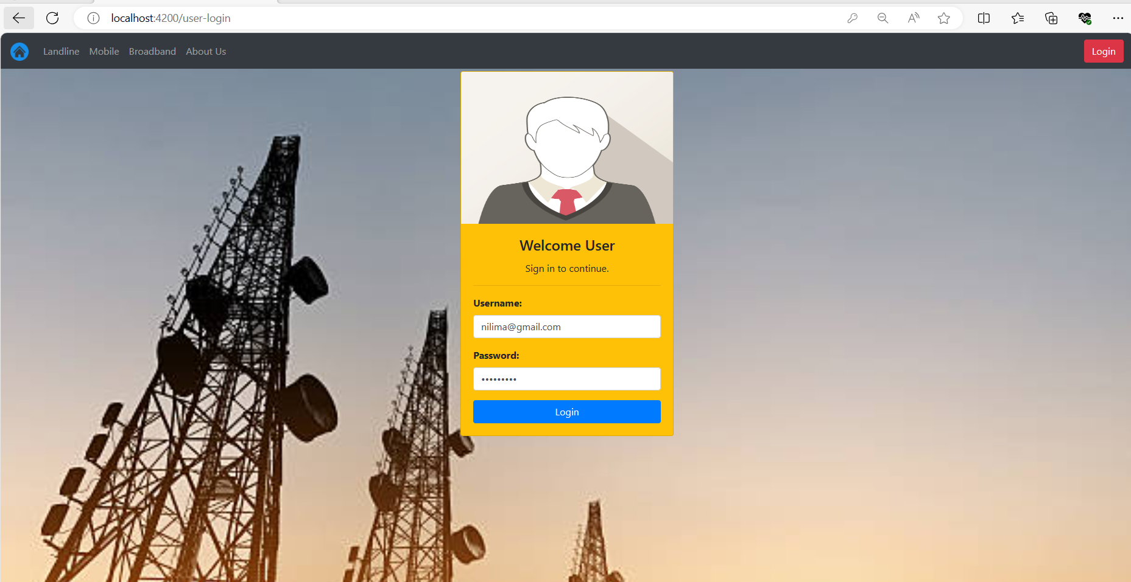

* The Customer have below responsibility:
* Raise Complaint
* Show Complaints

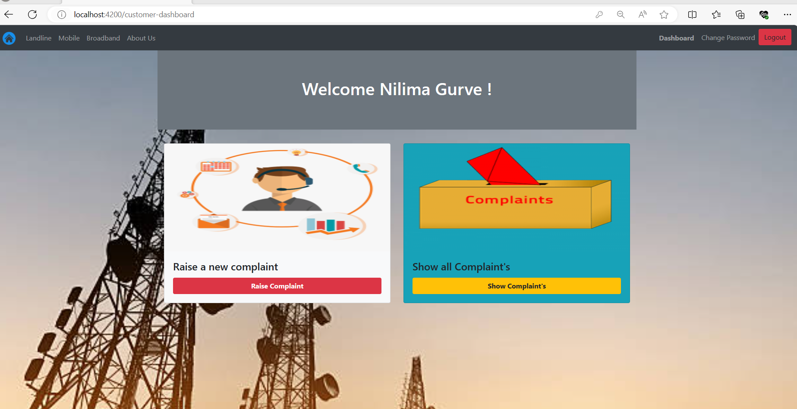

* Let’s raise the new complains using **Raise Complains options**:

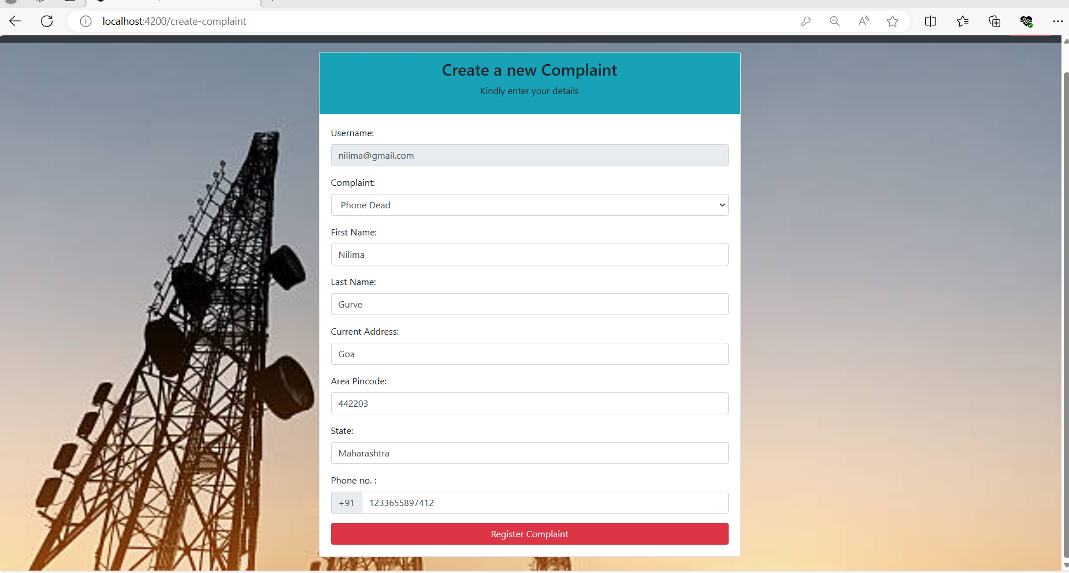

* Once you clicked on Raised Complains below screen will appear

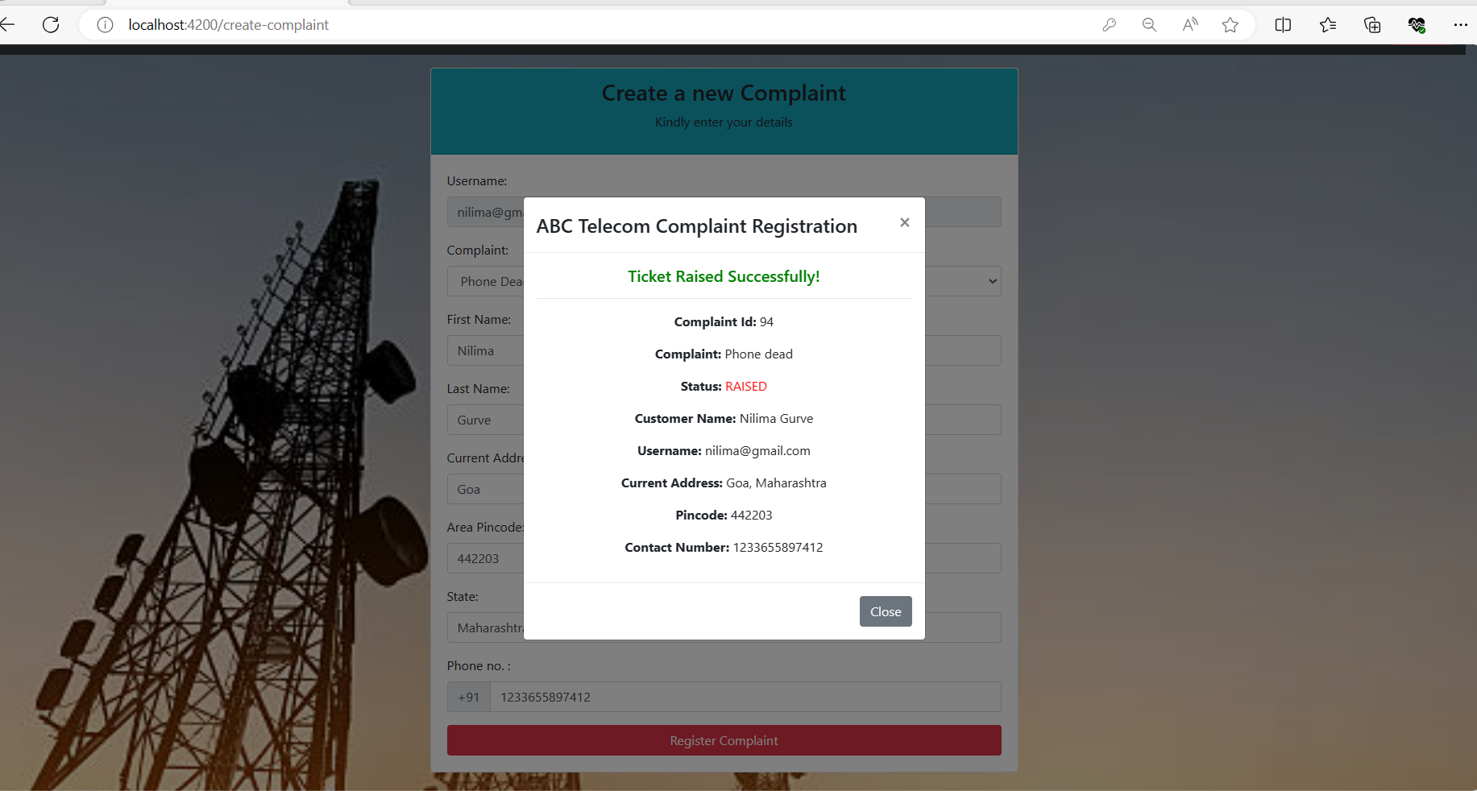

* **Show Complaint option**: show the all complaints raised by user and there status as well feedback option to gives the feedback:

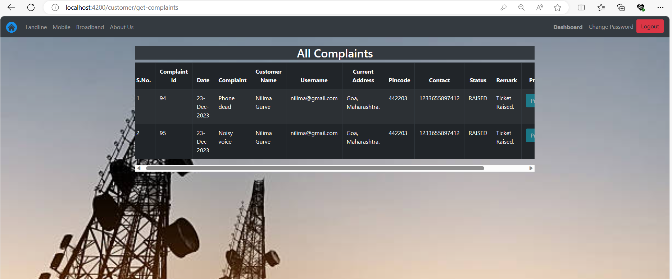

* Let’s Logout as Customers, Try to login as **new Manager**:

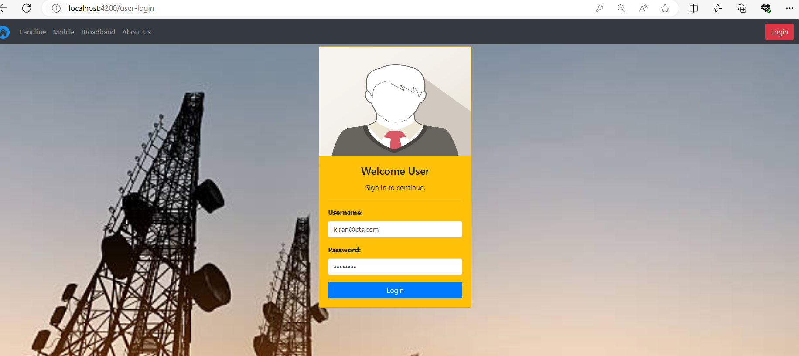

* The Manager have Below Responsibilities:
* Assign Engineer
* Show Complaints
* All complaints
* Show Feedback

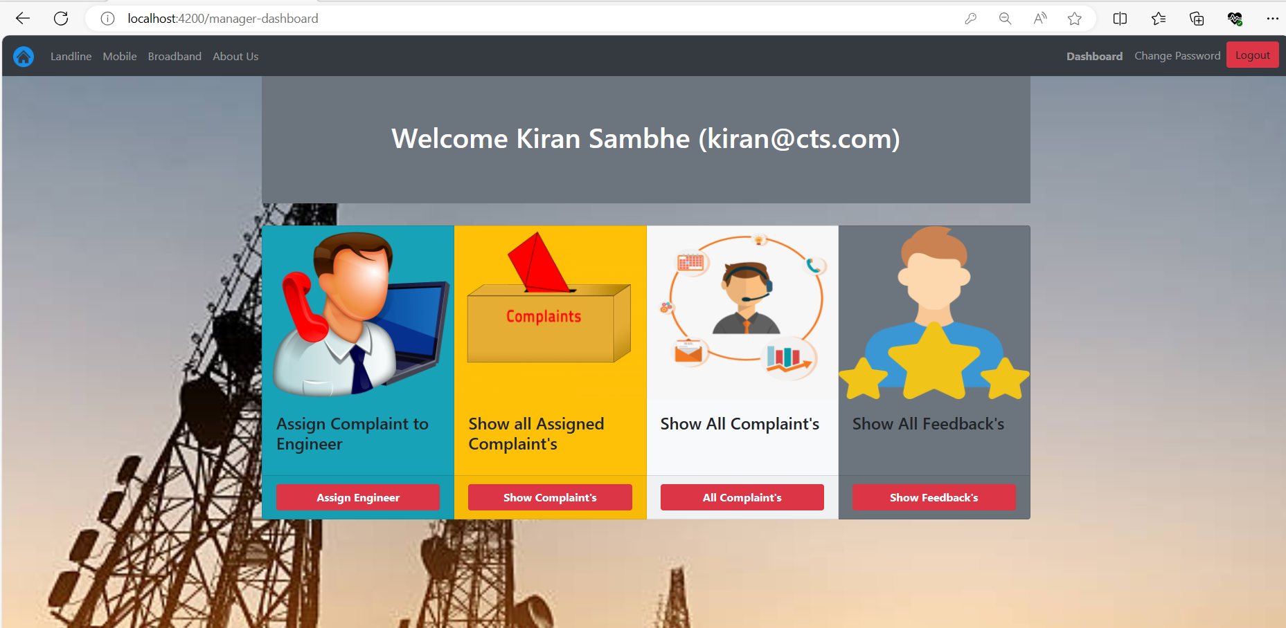

* **All Complaints option:** shows the all the available complaints:

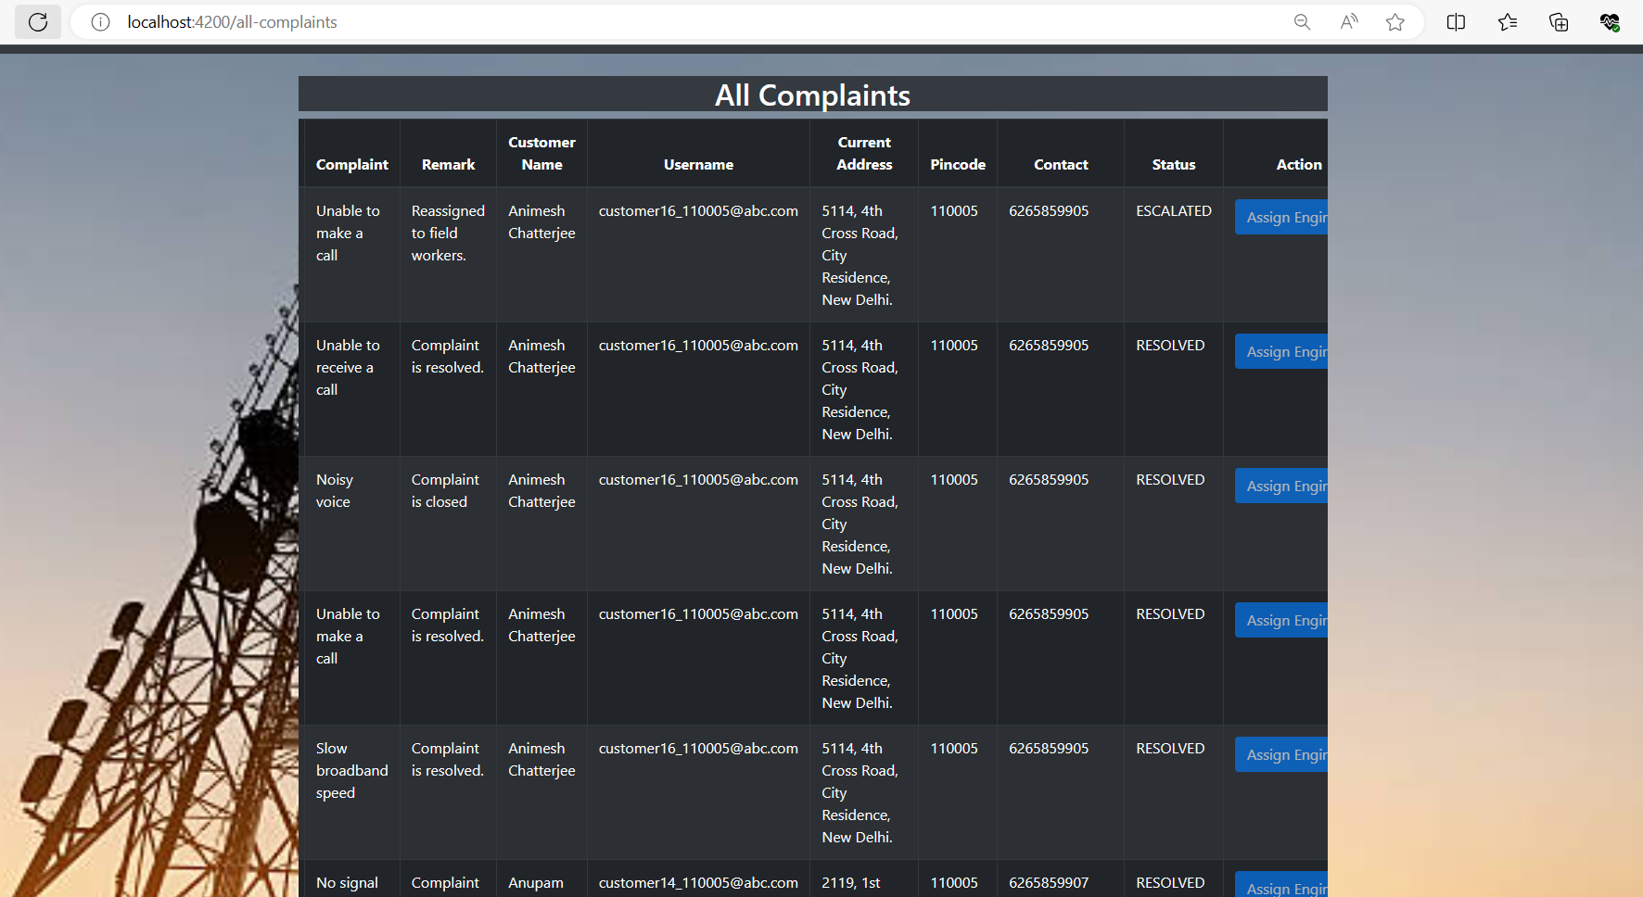

* Using Assign Engineer button, the manager assigns complaints to engineer:

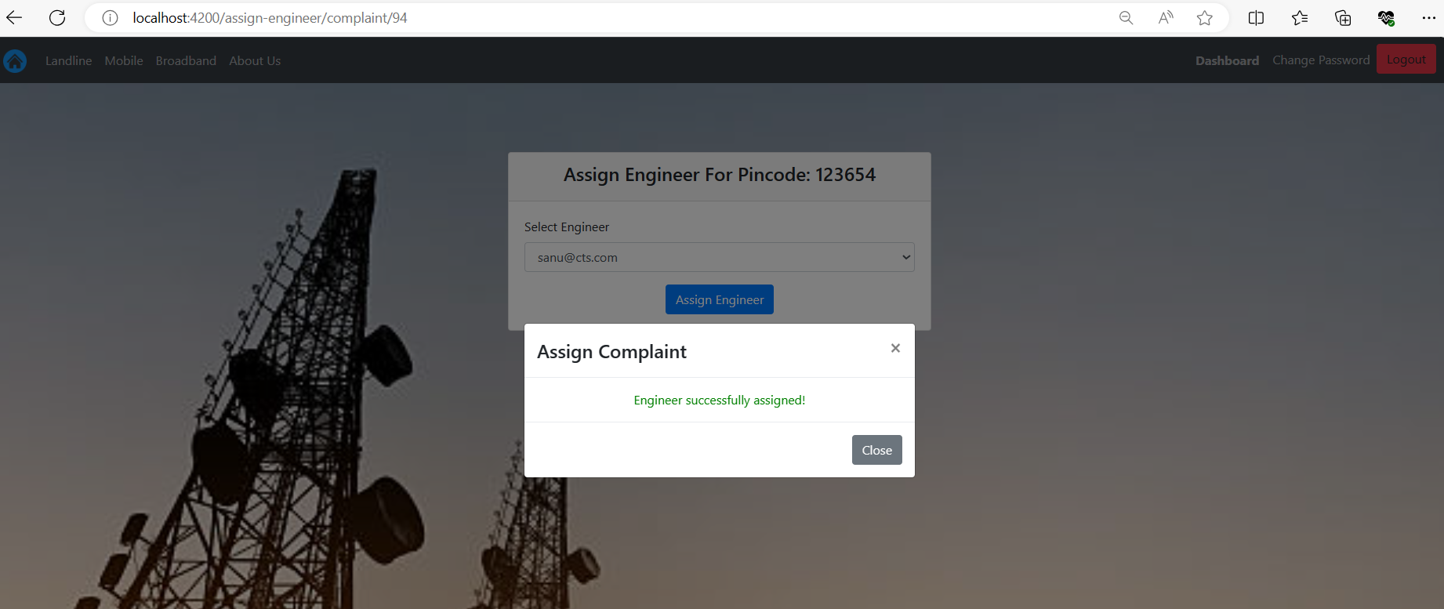

* Assign Engineer option: Shows All unassigned complaints:

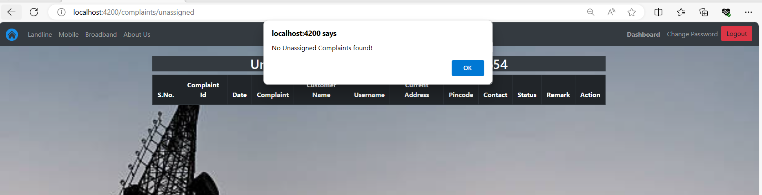

* **Feedback option** show the all the available feedback to manager:

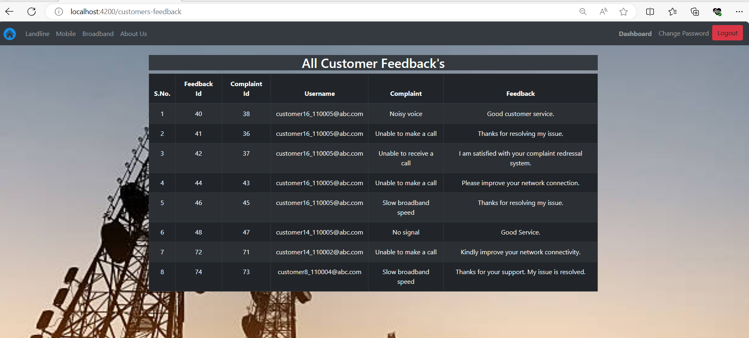

* Let’s logout as Manager, Try to login as **New Engineer**:

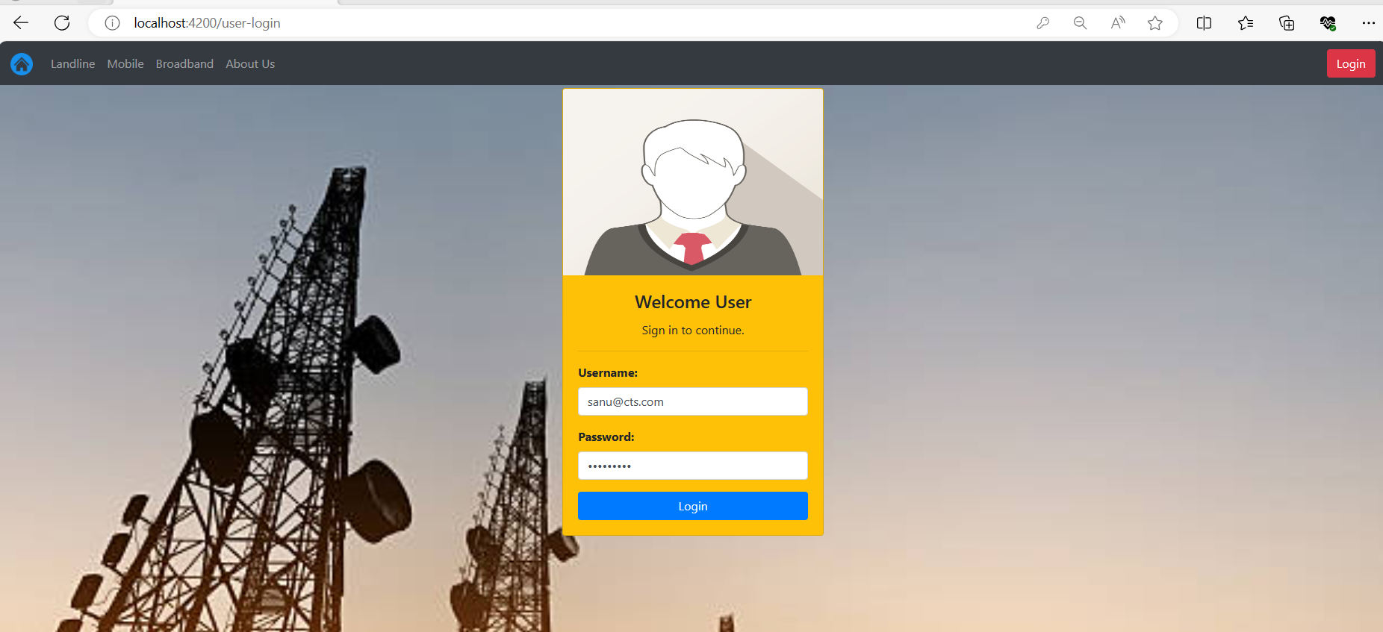

* The Engineer has below responsibilities
* Show Complaints
* Show Feeback

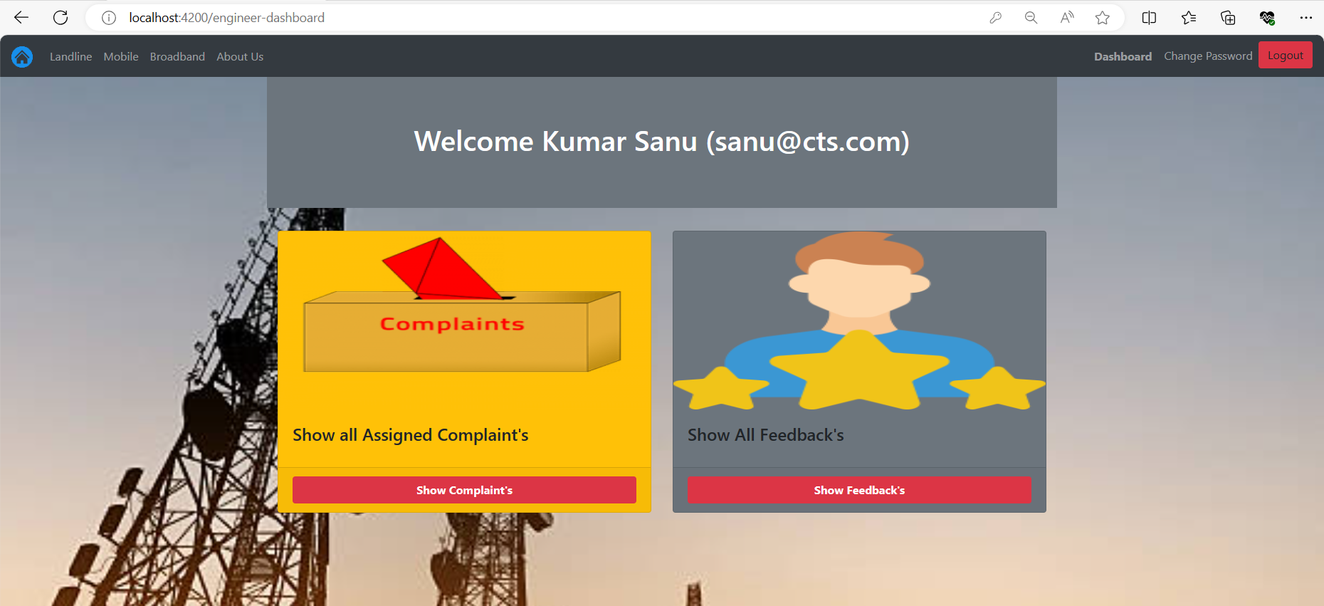

* **Show Complaints option:** Shows all complaints assigned to enginner:

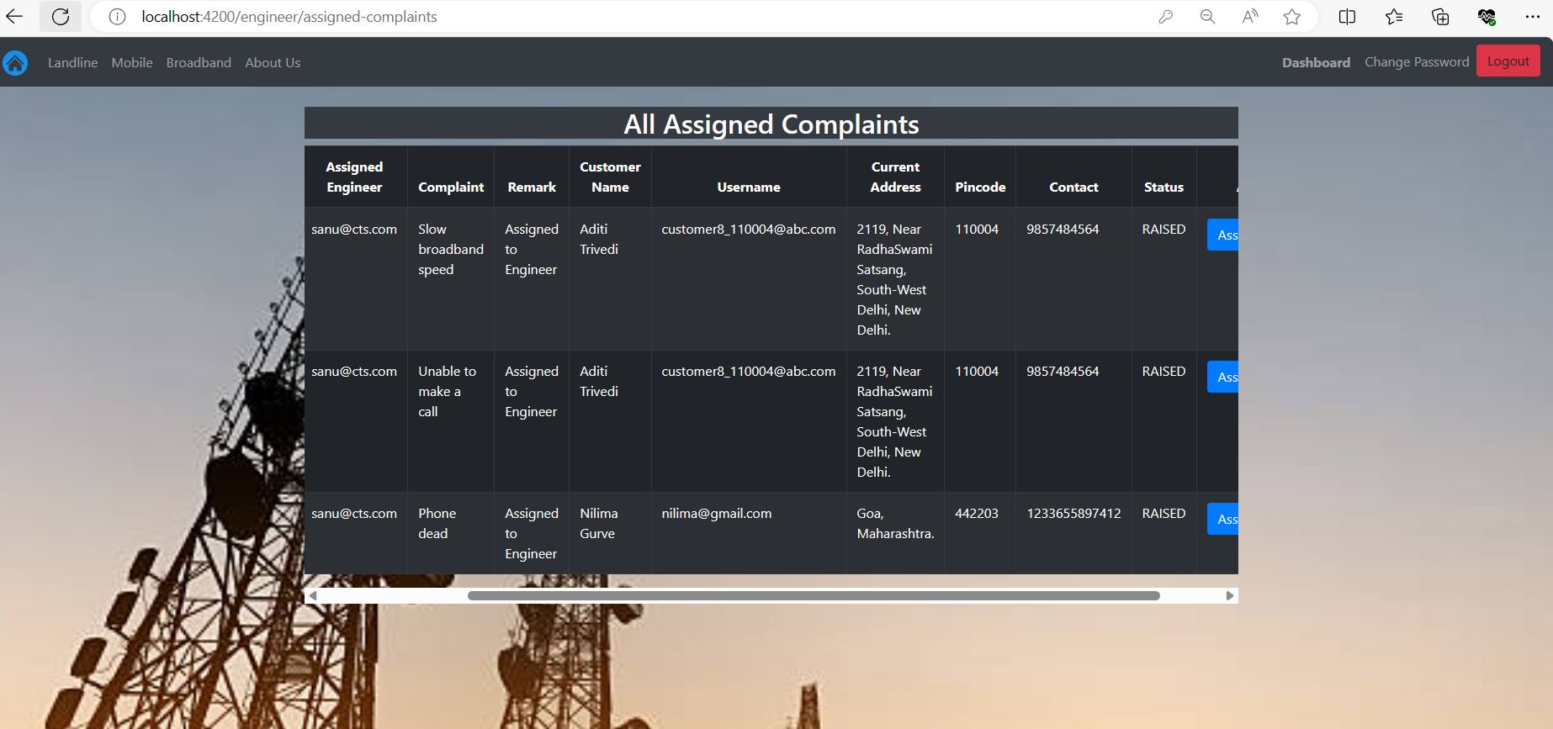

* Using assigned status button engineer can updated the status of ticket:

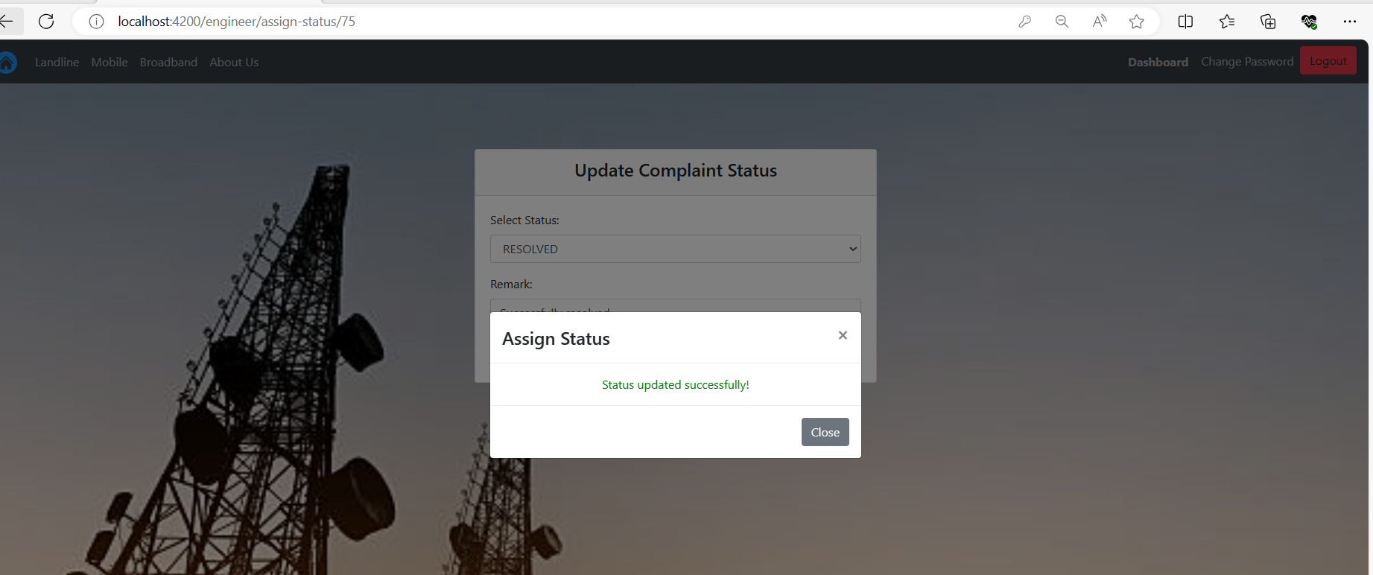

* **Feedback option** show the all the available feedback to Engineer:

